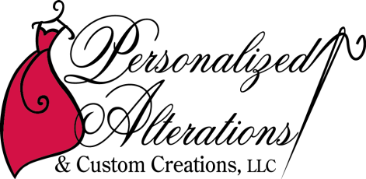Making your special occasion attire perfect --- just for you!

Full service alterations & custom sewing business. We specialize in formalwear for male & female clients, young to elderly. We do alterations & repairs to anything we our hands & machines can handle. We also make garments from scratch if requested.

Why ‘Personalized’ is part of our name:
- All fittings are scheduled in 60 minute increments, to allow time for client to become comfortable with us, and do a ‘truly’ custom tailored fitting.
- Ensure correct fitting undergarments (most females wear the wrong size and/or type of bra for their body shape & size). Instruct clients on how to determine the correct bra prior to purchase.
- Ensure garment is laying on the body in the correct positions per the design of the dress.
- Thorough check of fit and appearance prior to client taking garment from our store.
Why ‘Custom Creations’ is part of our business name:
- We redesign garments to make the ‘perfect dress for your occasion’. Example: Turned an A-line bridal gown with a long train into a custom form-fitting gown with a shorter train. Also took it from a size 10 to a size 2.
- Custom make clothing from scratch.
- Sell custom-made jewelry designed & created by a local jewelry artist. ‘Individualized’ custom-made jewelry designed by client & jewelry artist, created by same jewelry artist.
- Sell custom-made gifts by a local talented ‘glass-etching’ artist.
Final test before garment leaves our premises:
- Strapless dresses do not need to be pulled up ‘every once in a while’.
- Anyone standing next to you will not see down your chest.
- When bending down, people will not see down your chest.
- Undergarments do not show.
- We make everyone with a strapless garment jump & dance to make sure dress does not slip down, slide around, or gap. If it does, we do whatever magic needs to be done to make it pass the test. Two–sided body tape is not an option in our opinion.

We do all this because every item that leaves our store is an advertisement of our work in appearance & quality.

- PACC is the only ‘Regional Alterations business set in an 1800 sq. ft. commercial space designed for what we do’.
- Large fitting room with 6 full-length mirrors. Small fitting room with 2 full-length mirrors.
- Every client gets 1 on 1 treatment.
- We have a very unique Consignment business which allows for NEW & ‘almost’ new bridal gown, mothers dresses, men’s suits, bridesmaid dress selection, shoes, jewelry, and accessories.

Additional points:
- We provide Instructional services to clients PRIOR to them purchasing a dress; helping them be an educated shopper to minimize alterations costs & dress purchasing costs.
- Problems/issues with internet purchased dresses.
- Why alteration costs are different between people/places who perform alterations.
- Rent versus Buy items.

